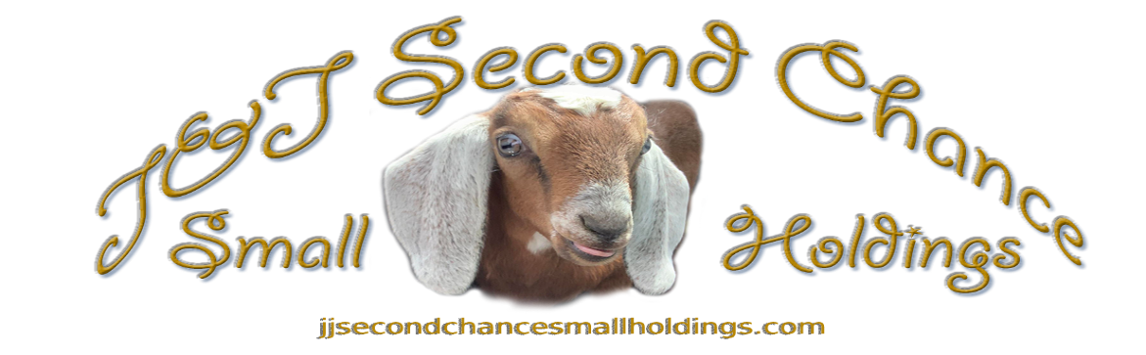
Shirt Order Forms

Name ______________________
Date ___________ Paid_______

Address____________________
__________________________________
Town______________________
State____ Zip code___________
Phone #____________________
Shipping Cost _______________

T-Shirts Adult
XS
Small
Medium
Large
X-Large
XX-Large
XXX-Large (+2)
T-Shirt Kids
XS
Small
Medium
Please choose your design-
1. Goat Therapy
2. No longer adulting!
Large
X-Large
One size Onesie
Sweatshirt (Circle One) XS S M L XL XXL XXXL
Long Sleeve Shirts (Circle One) XS S M L XL XXL XXXL
6% Wyoming State Tax
Total # of Items____________
Design #________
_____X $25 =_______
_____X $25 =_______
_____X $25 =_______
_____X $25 =_______
_____X $25 =_______
_____X $25 =_______
_____X $27 =_______

_____X $18 =_______
_____X $18 =_______
_____X $18 =_______
_____X $18 =_______
_____X $18 =_______
_____X $20 =_______
_____X $45 =_______
_____X $30 =_______
X 0.06 =_______
Total Cost___________

